Design Report

For Introduction to Web Design (DECO1400)

By Jianwei Li (45555408)

In terms of the structure of HTML, I mainly use structures such as HEADER, NAV, SECTION, ASIDE, FOOTER, which are clearly structured and categorized.

In the "Contact Us" page, it is more inclined to use the layout of HEADER, NAV, ARTICLE, FOOTER, which is conducive to the addition of a large amount of text.

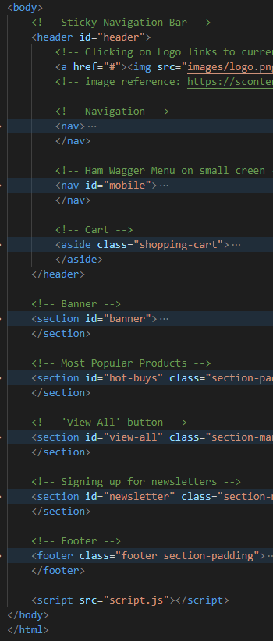 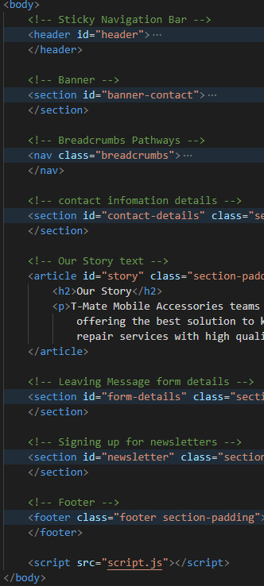

In terms of CSS design, the website adopts a simple theme, highlights the products, makes the website more technological. Through a unique HEADER, and a unified format FOOTER and allows users to focus more on the products they need without being distracted by complex interfaces. When the user moves the mouse over a product, the pictures and information of the product will have magnification and shadow effects.

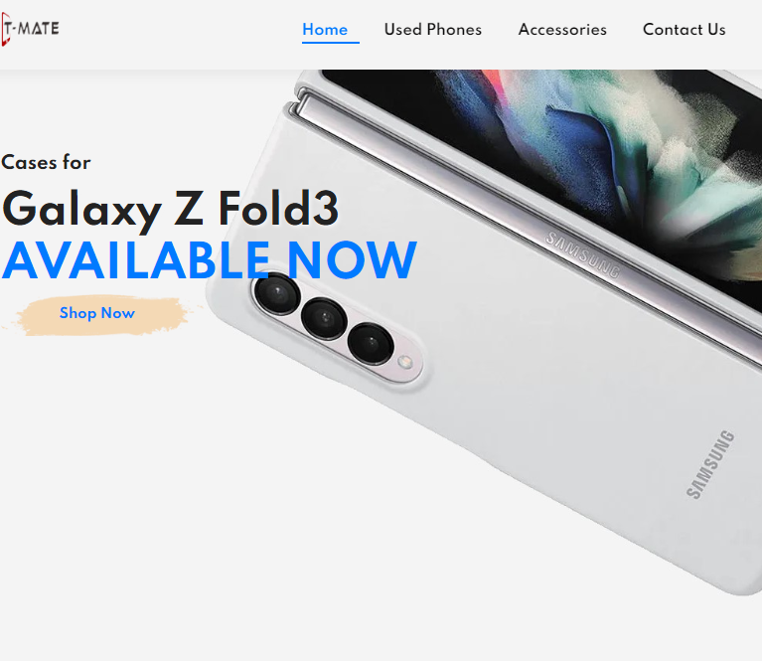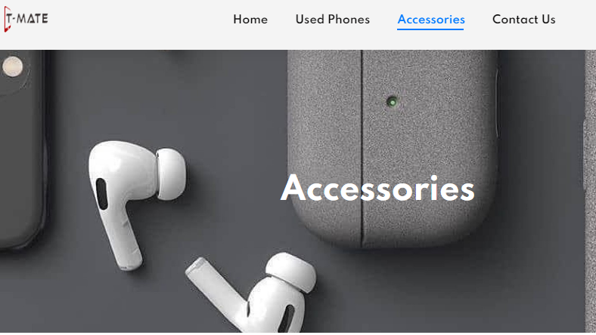

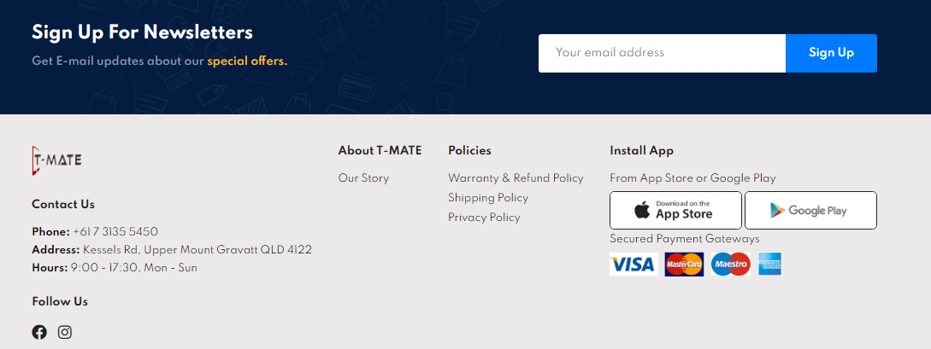

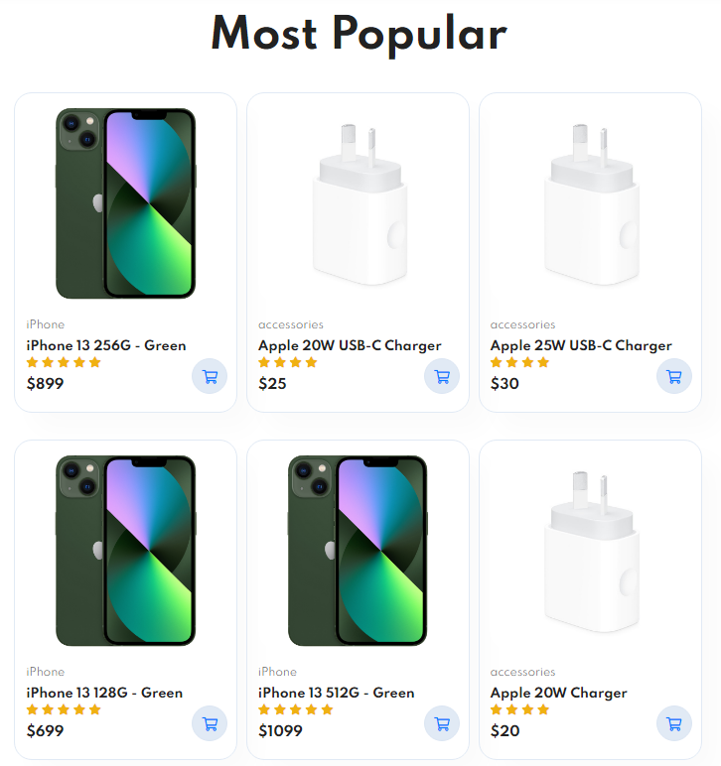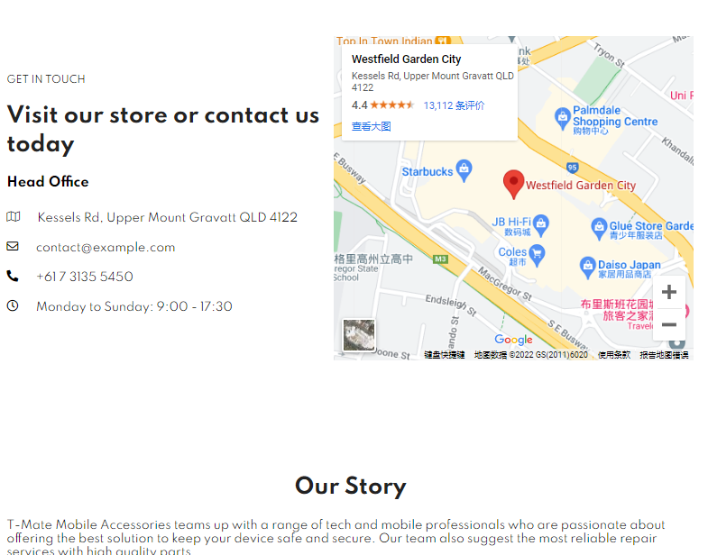

JAVASCRIPT special effects mainly add the functions of opening or closing the side shopping cart, adding items to the shopping cart, the shopping cart automatically calculates the total price, and the multi-picture window of the item.

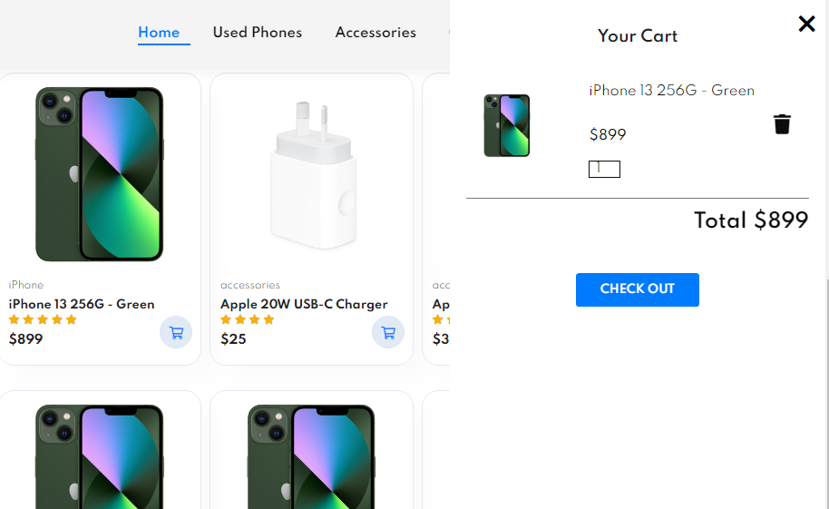

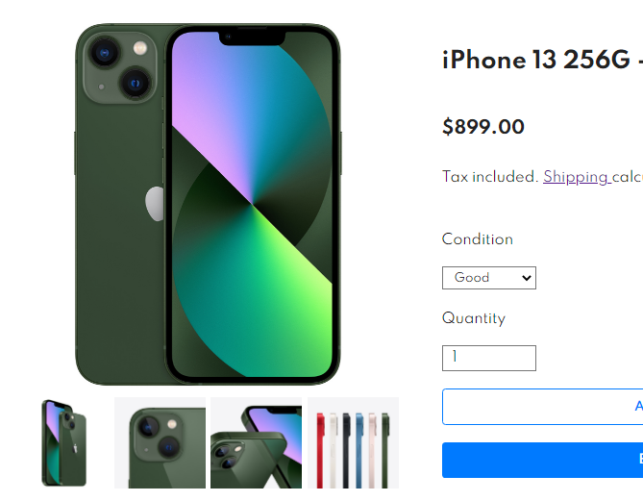

Based on **Recognition rather than recall**, **Flexibility and efficiency of use**

the floating navigation bar is always displayed at the top of the page, the user can always see the navigation bar in the line of sight, and can easily access the personal account and shopping cart.

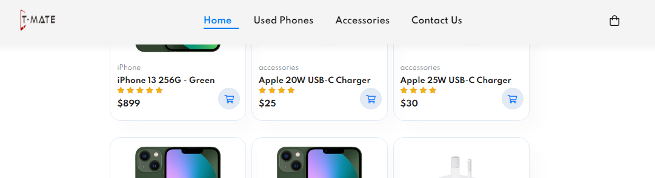

Based on **Visibility of system status**,

the bar that displays the current web page position and the bar that displays the page number can clearly tell the user what content is currently being accessed and how to jump to view information on other pages.

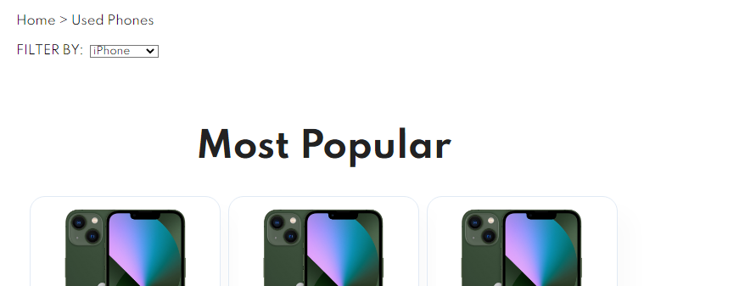

Based on **Consistency and standards** & **Aesthetic and minimalist design**,

the pages are all in a similar layout, and the displayed products are all in a 4x3 layout, pages and product descriptions contain only the most important information, eliminating redundant information.

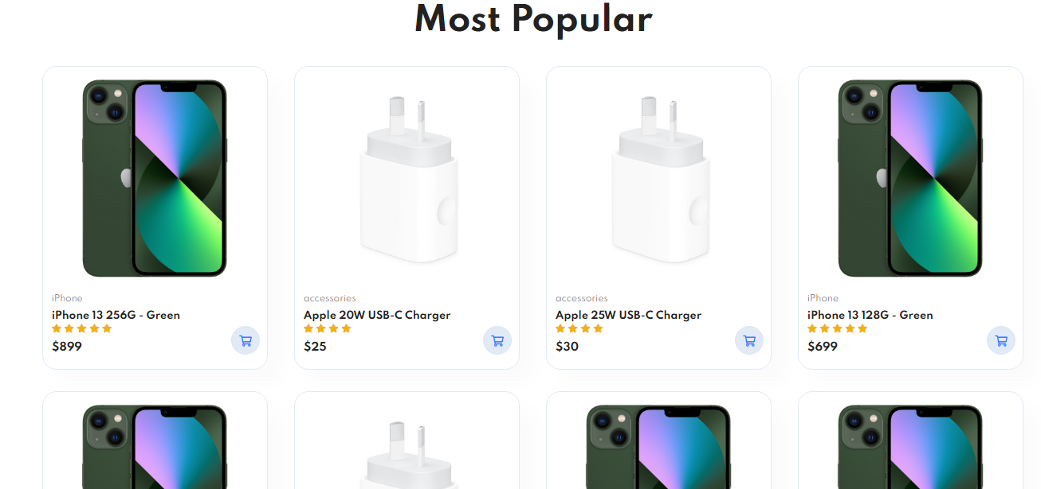

Based on **Match between system and the real world** & **User control and freedom**,

the feature description of the product adopts user language and abandons display parameters.

There is an obvious return button at the bottom of the page. When the user mistakenly clicks on an uninteresting product and enters this page, he can quickly return to the previous page.

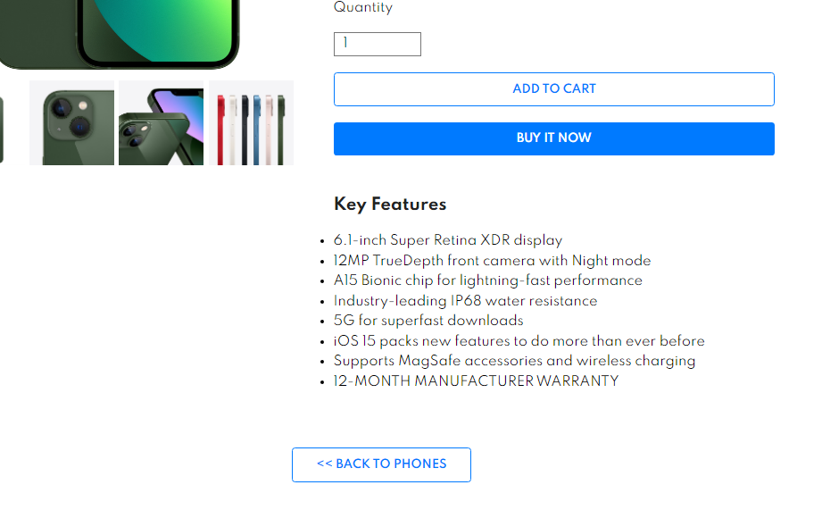

Based on **Error prevention**, **Help users recognize, diagnose, and recover from errors** & **Help and documentation**

If the user misses an item, when the user clicks submit, the missing item will be displayed in red to remind the user to correct the error.

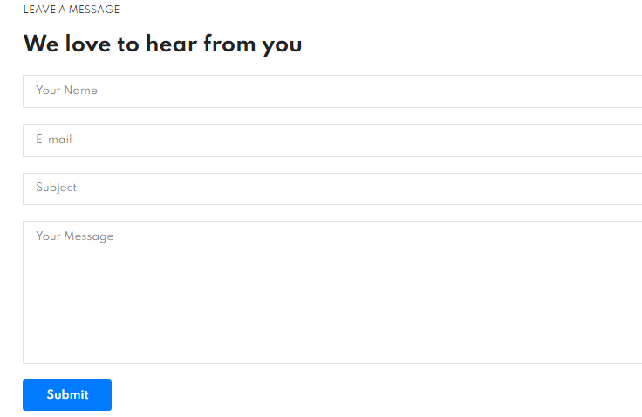

Conclusion

The biggest challenge I encountered was the use of the prototype tool, I needed to get familiar with how to use the tool, add effects, and logically link related pages through the use of events, which really took a lot of time.

At the same time, adding special effects to JAVASCRIPT is also another problem. When writing scripts, the massive variable names and unfriendly DEBUG functions took me a long time.

This course taught me how to design and implement functional responsible web pages using HTML, CSS and JAVASCRIPT.

The next work is to gradually implement the designed web page, but at the same time, it will also face a bigger challenge, that is building a database, because the website needs to access the established database for loading product information and loading user personal information. Therefore, in the future work, I also need to learn the technology of building and accessing the database from the web page.